Kids’ Club and Tumble Room October 2019
Sun | Mon | Tue | Wed | Thu | Fri | Sat
 |  | 1 CCPS Closed  Crazy Hair Day! | 2  Kids’ Club Recess  9:45-10:30am  in Gymnasium | 3  Colors of Fall | 4  Kids’ Club Recess  9:45-10:30am  in Gymnasium | 5
6  Fire Prevention Week Begins.  Do you have and practice your escape plan? | 7  Kids’ Club Recess  9:45-10:30am  in Gymnasium | 8  Sparky Says | 9  Kids’ Club Recess  9:45-10:30am  in Gymnasium | 10  Fire Fighter Craft  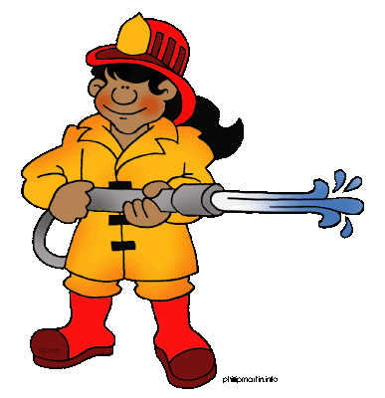 | 11  Kids’ Club Recess  9:45-10:30am  in Gymnasium | 12
13 | 14  Kids’ Club Recess  9:45-10:30am  in Gymnasium | 15  Jack O’ Lanterns | 16  Kids’ Club Recess  9:45-10:30am  in Gymnasium | 17  Silly Sock Day  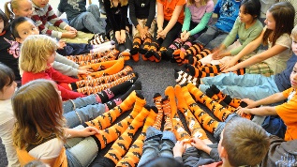 | 18  Kids’ Club Recess  9:45-10:30am  in Gymnasium | 19
20 | 21  Kids’ Club Recess  9:45-10:30am  in Gymnasium | 22  Pumpkin Patch Craft  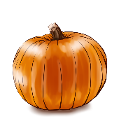 | 23  Kids’ Club Recess  9:45-10:30am  in Gymnasium | 24  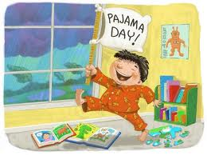 | 25  Kids’ Club Recess  9:45-10:30am  in Gymnasium | 26
27 | 28  Kids’ Club Recess  9:45-10:30am  in Gymnasium | 29  Funny Face Craft | 30  Kids’ Club Recess  9:45-10:30am  in Gymnasium | 31  Costume Dress Up  and Parade  No Evening  Kids’ Club Hours

